

**Petra University**

**Faculty of Information Technology**

**Graduation Project Documentation**

eBlood

Prepeared by:

Hisham Abu-Snaimeh 201110270

Khalid Al-Hussein 201120009

Abdullah Abd Alhadi 201120354

Tasneem Hassan 201310537

Supervised By:

“Dr. AbdulKarim Al-Banna”

Date: 2015/2016

Second Semester

**Abstract**

Blood shortages at hospitals and health centers have always been a major problem. It could cause unnecessary deaths. That's why we thought about developing an application that could ease the process of donating blood units. It assists patients to find the right blood group they are looking for. The patients can easily search for the nearest medical institution that provides this blood group only by entering their information. Or they can choose to contact a donor directly. The application displays a map that shows the location and information of the donors and the medical institutions. It also helps the blood donors choose to donate blood to medical institutions or to patients directly. Donating blood can benefit the donors’ bodies by reducing risk of heart disease and cancer. However, they are not allowed to donate more than one blood unit during a specific period of time. So, the application disables the donor once he/she donates blood, he/she can’t request to donate again for three months.

**Acknowledgement**

As we express our gratitude, we must never forget that the highest appreciation is not to utter words, but to live by them. (John F. Kennedy, 1963)

We would like to dedicate this work to our beloved parents, families, friends, and to our teachers who planted the seeds of knowledge inside us, thank you for guiding us, inspiring us and for making us who we are today. Especially Dr. AbdulKarim Al-Banna thank you for the help you provided and for believing in us and in our project. And a special thanks to the dean Dr. Ghassan Issa for providing a convenience environment that enabled us to succeed and finish the requirements of this project.

Table of Contents

Chapter I 1

Project Initiation 1

1.1Problem Overview 2

1.2 Current/Existing Systems: 3

1.2.1 Existing Systems: 3

1.2.2 Current System: 4

1.3 Purposes/Goals of the project: 5

1.3.1 Goal no.1 5

1.3.2 Goal no.2 5

1.4 Stakeholder Analysis: 6

1.5 SWOT Analysis: 7

1.6 Project Constraints: 8

1.6.1 Solution Constraints: 8

1.6.2 Product constraints: 8

1.6.3 Time Constrains: 8

1.7 Cost estimation and Budgeting: 9

1.7.1 Developer Budget: 9

1.7.2 Recourse Budget Case tools 9

1.8 System Development tools and requirements: 9

1.9 Gantt Chart and Resource Planning: 10

Chapter II 12

2. Literature Review 13

2.1 Introduction 13

2.2 Why should people donate blood? 14

2.3 Traditional Blood Donation 14

2.4 Blood Donation Applications 14

2.5 An Android App for volunteer blood donors 15

2.6 Blood monk: 15

2.7 Conclusion: 16

Chapter III: 17

Planning and Requirements 17

3.1 Scope Diagram and Domains of Interest: 18

3.2 Business Events: 19

3.3 Requirements Gathering and Trawling Techniques: 20

3.3.1 Brainstorming 20

3.3.2 Interview 20

3.3.3 Web search 20

3.4 Product use-case scenario: 21

3.4.1 User Register: 21

3.4.2 User login: 22

3.4.3 User Donate Blood 23

3.4.4 User Request blood: 24

3.3.5 Medical institution Register 25

3.3.6 Medical institution login 26

3.3.7 User Edit Information 27

3.3.8 Admin login 28

3.3.9Admin manage medical institutions 29

3.3.10 Medical institutions manage Information 30

3.3.11 Locate position 31

3.4 Functional requirements 32

3.5 Non-Functional Requirements: 35

3.5.1 Look and Feel: 35

3.5.2 Usability Requirements: 35

3.5.3 Performance Requirements 35

3.5.4 Security Requirement 35

Chapter IV 36

System Analysis Design 36

8.1 Project’s Main Features: 37

4.2 Use Case Diagram: 39

4.3 Activity Diagram: 40

4.4Sequence Diagram: 44

4.6 component diagram 52

4.7 ERD Diagram 53

Chapter V 55

Implementation 55

5.1 Process Model 56

5.2 Main features 56

5.2.1 Feature no.1 56

5.2.1 Feature no.1 58

6. Testing 60

6.1 Requirement Testing 60

6.2 System Testing 63

Conclusion 85

Future Improvements 85

Appendix A: 86

**Table of Figures**

Figure 1GanttChart 10

Figure 2GanttChart Timeline 11

Figure 3scope 18

Figure 4table of events 19

Figure 5Main Features 40

Figure 6-usecase 41

Figure 7- Activity diagram for user registration 42

Figure 8 activity for login 43

Figure 9-Activity diagram for user request blood 44

Figure 10-Activity diagram for user donate blood 45

Figure 11- sequence diagram for user registration 46

Figure 12 sequence login 47

Figure 13- sequence diagram for user request blood 48

Figure 14-- sequence diagram for user donate blood 49

Figure 15- statechart user registeration 50

Figure 16statechart login 51

Figure 17statechart donate blood 52

Figure 18satetchart forrequesting blood 53

Figure 19 component diagram 54

Figure 20ERD Diagram 55

Figure 21class diagram 56

# Chapter I

# Project Initiation

**1. Initiation**

## 1.1Problem Overview

Blood is the fluid that delivers necessary substances such as nutrients and oxygen to the cells and transports metabolic waste products out of the body. The components of blood include plasma (the liquid portion, which contains water, proteins, salts, lipids, and glucose), red blood cells and white blood cells, and cell fragments called platelets.

Every second of every day, people around the world of all ages need blood transfusions to survive. The reasons for transfusion vary but the need for blood is ever present and growing.

The importance of blood in our bodies is undeniable. However, some blood groups are just rare and very hard to find. Patients with blood group O-Negative for an example can’t receive any other blood group than O-Negative. which is very rare to find, as only 7% of people around the world have this blood group.

This application aims to aid patients by making it easier to find the blood group they are searching for. The users of this application do not have to search for blood units in numerous hospitals or health centres but rather, the use of this application will make the processes much easier. This not only saves time and money, but in critical times it could save lives.

The users register and enter their information and their location. The application displays a map that shows the medical institutions, donors and requests. And enables the users to donate or request blood. This application is accurate, fast, secure and its interface is user friendly and easy to deal with.

## 1.2 Current/Existing Systems:

### 1.2.1 Existing Systems:

While searching for similar applications on the web, we found a few, and these are the most common.

#### 1.2.1.1 Blood Monk

The application Blood Monk is an android application that allows users to view blood donors’ database and contact them. It also lets users to find the nearest blood banks around their home area. This application is available in certain cities that the application allows only. (Google play store, 2015)



#### 1.2.1.2 Blood Members Nepal

This application helps to find blood donors when needed online instead of searching in blood banks. And lets the users to send a request for a blood donor, the blood donor finds the request and reach the users. This application is only available in Nepal. (Google play store, 2014)



### 1.2.2 Current System:

#### eBlood

This application helps the donors to easily search for medical institutions and patients to donate blood units. It also helps the patients to find the medical institutions that have the blood group they are looking for, instead of searching and visiting all the blood banks in the area looking for the specific blood group, they easily enter the application and search. The application also allows the medical institution to request and receive blood requests.

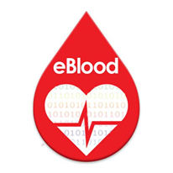

## 1.3 Purposes/Goals of the project:

## This application is developed for so many goals and purposes, and these two goals are the most important.

### 1.3.1 Goal no.1

**Purpose:** to assist hospitals and patients to find the requested blood group.

**Advantage:** to avoid unnecessary deaths.

**Measurement:** reduce the time spent on searching for hospitals and health centres by 100% since the blood banks database shall be available for users all the time.

### 1.3.2 Goal no.2

**Purpose:** to encourage people to donate blood more often.

**Advantage:** to decrease the blood unit shortages, and to reduce the risk of heart diseases and cancer for the donor.

**Measurement:** the percentage of blood donors shall be increased above the yearly percentage 5%.

## 1.4 Stakeholder Analysis:

**This table below shows the stakeholders for this application, their interest and the importance for each one.**

|  |  |  |
| --- | --- | --- |
| **Stakeholder** | **Interest/Stake** | **Importance** |
| **Tasneem** | Team Member/  Documentation & Analysis | High |
| **Hisham** | Team Member/  Code, Design & Documentation | High |
| **Khalid** | Team Member/  Code & Design | High |
| **Abdullah** | Team Member/  Code & Design | High |
| **Dr. Al-Banna** | Supervisor | High |
| **Dr. Izz Al-Dein Mattar** | Instructor | Low |
| **Dr. Ahmad Shubeita** | Instructor | Low |
| **Patient** | User | High |
| **Donor** | User | High |
| **Medical institutions** | User | High |

Table 1 - Stakeholder Analysis

## 1.5 SWOT Analysis:

Internal

## SWOT Analysis is an acronym for strengths, weaknesses, opportunities, and threats for this application.

|  |  |
| --- | --- |
| **Strengths** | **Weaknesses** |
| **-**Each member of the team has a set of skills that contributes differently in building up this project.  -Some team members had a past experience developing such applications with the same programming language.  -All of the team members have good hearts and work well as a team. | **-** Most of the team members are still under  Training.  -No one of the team members is expert in writing documentations. |
| **Opportunities** | **Threats** |
| -Save people’s lives.  -Reduce blood shortages in blood banks.  -Save time for patients.  Positive | -The time may not be enough.  Negative  -The competition level is very high between similar applications. |

Table 2 - SWOT Analysis

External

## 1.6 Project Constraints:

## Here are the restrictions that define a project's limitations.

### 1.6.1 Solution Constraints:

1. The mobile application is only available for android users.
2. The mobile application will use GPS.
3. Active internet connection is needed for the GPS accuracy.

### 1.6.2 Product constraints:

### Time Constrains:

1. The project is due on 24/5/2016 and it must be finished before that date.
2. Time period assigned for the completion of each phase might be insufficient.
3. Coding the application and filling the database need too much time.

**Cost Constrains:**

The application cost must not exceed the budget assigned for this project.

## 1.7 Cost estimation and Budgeting:

### 1.7.1 Developer Budget:

In this project there are 4 developers cost 5$/hour.

### 1.7.2 Recourse Budget Case tools

### 1.8 System Development tools and requirements:

1. Smart Draw.

2. Microsoft Project 2016

3. Android Studio.1.5.1

4. Adobe Photoshop.CS 6

5. Creately.

## 1.9 Gantt Chart and Resource Planning:

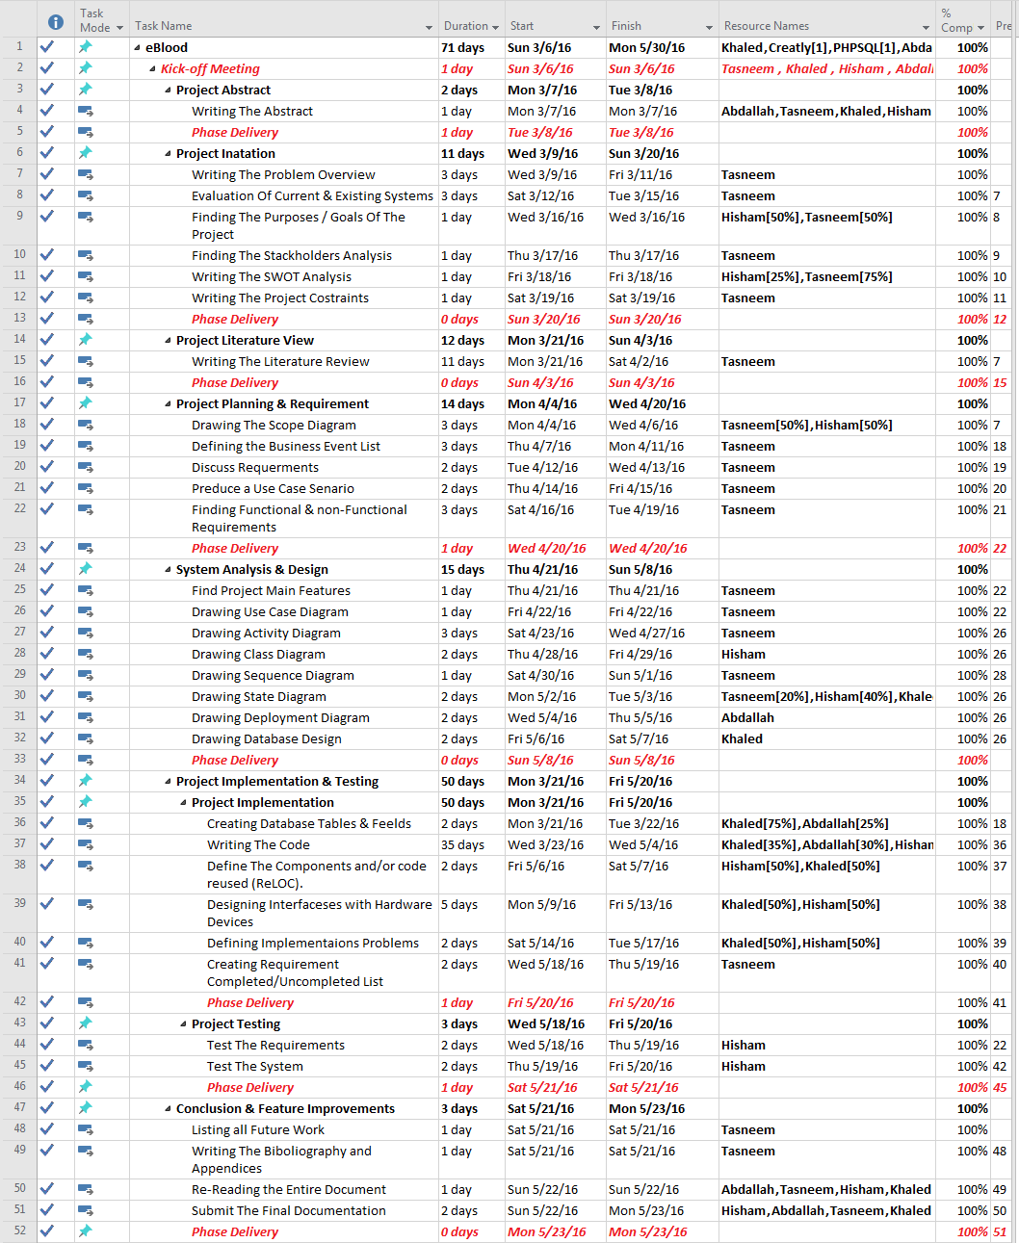

Figure GanttChart

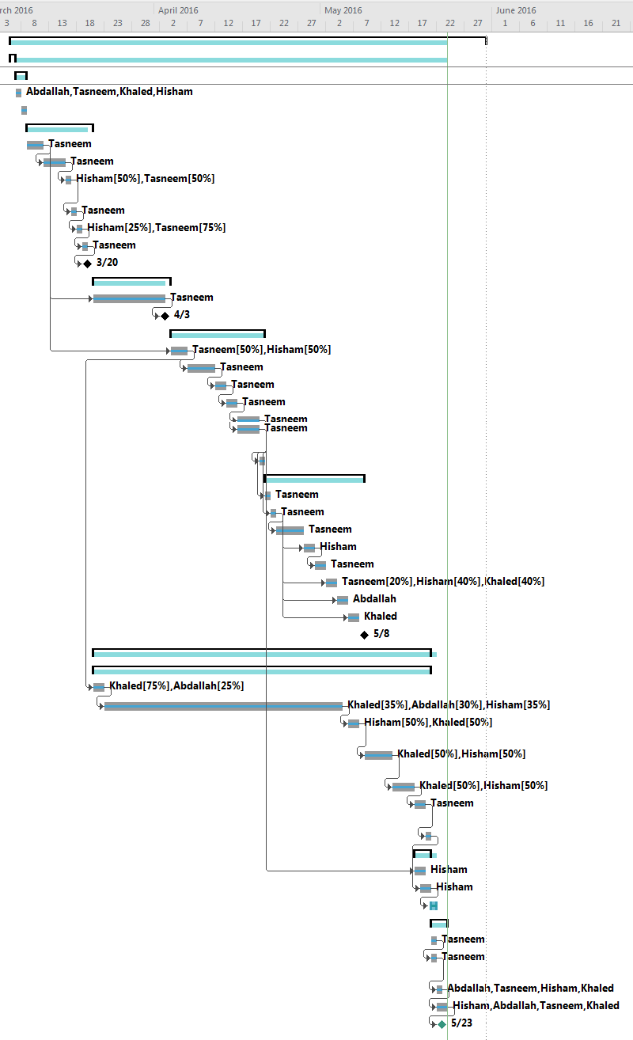

Figure GanttChart Timeline

# Chapter II

# Literature Review

# 2. **Literature Review**

## 2.1 Introduction

Blood shortages at hospitals and health centers have always been a big deal, that’s why the need of a solution for this problem is required. Blood donation applications may help to raise the sensibility about this case. Android mobile applications are made to help so solve this problem. However, there are some issues about these applications like; the applications are available for only a specific country, and many other disadvantages.

Blood is the red liquid substance that exists inside our bodies, Allah created it to transport the oxygen and food inside the arteries to our different body parts. The blood role in our body’s defense against infections is undeniable. Patients who need blood can get it from the blood donors only. Blood can be separated into four main elements; white blood cells, red blood cells, plasma and platelets. (Centers, 1999)

One of the first blood transfusions was given to a man who suffered from

In general, anyone who is adult and in good health (has not recently had any serious diseases) can donate blood. Potential Donors must fill a questionnaire to see if they have suffer from some illnesses or some kind of allergies before, and could be rejected as donors if they were not suitable for blood donating. (Mollison et al., 1997)

The first blood transfusion was given in 1667. (Mollison et al., 1997)

## 2.2 Why should people donate blood?

**1.** **Preserves cardiovascular health and decrease the risk f eart attacks**

Recent medical studies, showed that donating blood regularly helps to fix the blood pressure and cholesterol in the donor’s body. This could save them from getting heart attacks and cancer. (Borreli, L., 2013)

**2. Burns calories**

The process of donating blood burns almost 650 calorie. A donor who donates blood regularly loses some amount of weight. But it shouldn’t be looked at as a way for losing weight at all. Some medical institutions in some countries put condition on the donor’s weight, they mustn’t be less than 55 KG weight. (Borreli, L., 2013)

**3. Gives a free blood check-up and analysis**

For donating blood, donors get to be tested for syphilis, HIV, hepatitis and so many other diseases. A sample of the donor’s blood is saved for future tests and researches at some medical institutions. (Borreli, L., 2013)

## 2.3 Traditional Blood Donation

**Blood donation process:**

The donor must get ready before donating their blood, by getting themselves well hydrate, wear comfortable clothes and must have a healthy iron percentage in their bodies.

The donation process goes by several steps. The donor must register and give the health center their specific information. The health center asks the donor some private questions about their health history and places they’ve travelled. The doctors will check the donor’s temperature, pulse, blood pressure and hemoglobin level present in a sample of blood. They will cleanse the donor’s arm and insert a clean needle to the blood draw. The donation process at whole takes 8-10 minutes at most, the donor must feel comfortable during that time. The donor must have a snack or drink to refresh their body after the donation process, and must have a rest time before leaving the center. Donors must keep themselves healthy and hydrated at all times and avoid lifting heavy weights. (Rudman, 2005)

## 

## 2.4 Blood Donation Applications

There are different blood donation applications available in the market that offers so many services to ease the process of blood donation or requesting blood units.

Blood donation is a very noble act done by good people. Many persons love to do good for others and be productive elements in this society, nothing feels better than saving a human being from dying by giving them the blood unit they need. However, there will always be some difficulties faced. Like finding the right hospital to donate at and making sure that the blood you are donating is going to be in a good hand to be delivered to the right patient.

There are 188 applications developed about blood donation around the world, most of them were developed for android operating system. However, some of the applications can’t be installed or accessed. Few of them are available in more than one language. Most of them are made for specific countries, 45% of these applications only allows users to share information via social media. Almost all of them don’t provide recommendations about healthy blood donation. (Grimshaw and Russell, 2008)

## 2.5 An Android App for volunteer blood donors

The patient requests for blood. The system checks if the blood can be provided from the stocks. If not, the system checks the patient’s location and determines the nearest donor around them, and then sends them a notification. Donors receive the notification and respond to the request with yes or no via this application. The system decides first weather the blood can be provided from the stocks, and then calculate the needed time to get to the blood. If the donor agrees to donate blood for the patient that sent the request, the system tells the patient and gives them their information. (Turhan, 2012)

## 2.6 Blood monk:

The first step is to register to this application, and then search for the requested blood group by entering the blood unite the patient need, a list of blood donors in that area will appear. The users can call/message/contact the donor directly.

The user can view a list of all blood donors who are registered in this application, and all the blood banks. (Medical, 2015)

## 2.7 Conclusion:

Based in the literature review above, we have talked the advantages and benefits of blood donation. And then we talked about the process of traditional blood donation and went through satisfying details. And while going through the details of traditional blood donation process we found the need of developing an application to assist patients and donors to find the best health centers and get the best service they deserve. This application can get a benefit for all of the patients, donors, and medical institutions. Just imagine how many lives can be saved by using this application!

# Chapter III:

# Planning and Requirements

**3. Planning and requirements**

## 3.1 Scope Diagram and Domains of Interest:

A scope diagram is a diagram that is used to provide an initial high-level overview of

The entire processes that are executed in a system; it aims to help the reader

Understand the main features of the project.

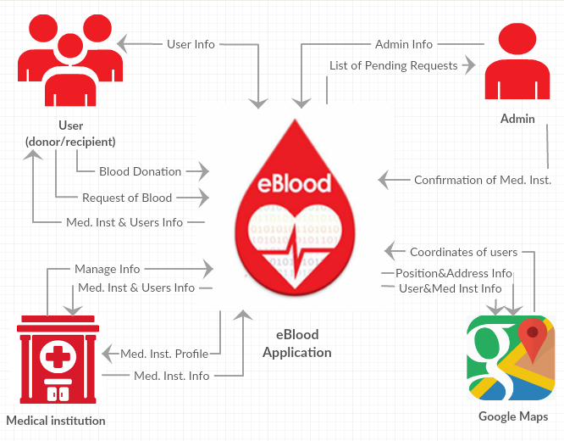

Figure scope

## 

## 3.2 Business Events:

|  |  |  |
| --- | --- | --- |
| No. | Event Name | Input / Output |
| 1 | Users Login | User's Info (in) |
| 2 | Users Register | User's Info (in) |
| 3 | User manage info | User's Info (out) |
| 4 | Donate blood | Blood donate(in) |
| 5 | Request blood | Blood request(in) |
| 6 | Display Med. inst. and donor’s info | All users Info(out) |
| 7 | Admin login | Admin’s Info (in) |
| 8 | Display pending requests | pending requests(out) |
| 9 | Admin confirm med. inst | Med. Inst. (in). |
| 10 | Medical Institutions login | Med. Inst. Info (in). |
| 11 | Medical Institutions register | Med. Inst. Info (in). |
| 12 | Display Med. inst. profile | Med. Inst. profile (out). |
| 13 | Manage Info | Med. Inst. Info (in). |
| 14 | Display med. inst. and donors info | Med. Inst. Info (out). |
| 15 | Send user coordinates | Coordinates(in) |
| 16 | Display Position | Position(out) |
| 17 | Display Med. Inst. and donors | Med. and users info(out) |

Figure 4table of events

## 3.3 Requirements Gathering and Trawling Techniques:

The requirements gathering step is the head-start to any project. In this project we used the following methods.

### 3.3.1 Brainstorming

In this project the main requirements elicitation technique is brainstorming; the team had to think through the list of all possible features that can be added to the application, and studied the team’s ability to implement each and every one of these features and how each feature will contribute in adding useful services for the benefit of the users of the application.

### 3.3.2 Interview

We had many interviews with stakeholders like Dr. Firas Nafith Al-Mohtaseb who works at the central blood bank at University of Jordan Hospital And Dr. Mohammad Younes Smadi the national public health officer in Jordan, who provided us with the needed information.

Review Appendix A

### 3.3.3 Web search

We used the internet to learn about the general procedure of blood donating and requesting.

Similar applications are one of the best sources for gathering requirements , we learned from the earlier projects and we are trying to develop an application that is better that them all, and covers all the missing functions in those applications. The internet was the easiest resource for collecting information about this project.

## 3.4 Product use-case scenario:

### 3.4.1 User Register:

**Scenario:**

New user registers in this application to start blood donating and requesting. User must enter his/her full name, nationality, ID, birth date, gender, blood type, address, email address, phone number and create a new password to use. Then the user presses the “current location” button on the map, then submits his/her and the application saves his/her information in the user’s database. The user can login easily now and enter his/her profile.

**Product use case name:** Users Register

**Product use case name and number:** Users Register(1)

**Trigger:** User Register in the application.

**Precondition:** The user must install application on his/her device and open it.

**Interested stakeholders:** User.

**Active stakeholders:** User.

**Normal case steps:**

1. User fills his/her information.
2. System checks the user information if they are valid.
3. User enters his/her location.
4. System gets location from GPS system.
5. System saves the information into the users’ database.
6. The system allows the user to enter the application.

**Alternatives:** None.

**Exceptions:**  
 1. Invalid information.

**Outcomes:**

The system shall allow the user to register and register successfully.

### 3.4.2 User login:

**Scenario:**

When a user wants to login to start donation and requesting blood, he/she must enter his/her email and password that were used in the registration, system checks the email and password and lets the user to use the application.

**Product use case name:** User Login

**Product use case name and number:** User Login(2)

**Trigger:** User Login to the application.

**Precondition:** The user must have an email and password.

**Interested stakeholders:** User.

**Active stakeholders:** User.

**Normal case steps:**

1. User enters his/her email.
2. User enters his/her password.
3. The system validates user info.
4. The system allows the user to enter the application.

**Alternatives:** None.

**Exceptions:**

1. Invalid Information entered.

**Outcomes:**

The system shall allow the user to login successfully.

### User Donate Blood

**Scenario:**

When the user logs in to the system, he/she can donate blood by requesting for blood donation. User fills the form, if he meets the conditions. Medical institutions and patients are showed on the map. He/she can choose who to donate for. If he/she chooses mecial institutions, his/her information is sent to the medical institution. If he/she chooses to donate for a patient, they can contact each other and the patient’s request is deleted from the map.

**Product use case name:** User Donate blood

**Product use case name and number:** User Donate blood (3)

**Trigger:** request for blood donation.

**Precondition:** Login to the application.

**Interested stakeholders:** User.

**Active stakeholders:** User.

**Normal case steps:**

1. User requests for blood donation.
2. User fills donation form.
3. System validates request.
4. System displays the medical institutions and patients.
5. User selects the medical institution.
6. System sends the donor’s information to the medical institution.
7. User selects to donate for a patient.
8. User contacts the patient.
9. System deletes the patient’s request from map.

**Alternatives:** none.

**Exceptions:**

1. Invalid information in the form.

**Outcomes:**

The system shall allow the user to search for the medical institution or patients requests as they want.

### 3.4.4 User Request blood:

**Scenario:**

When the user logs in to the system, He/she fills the request form. And then view the medical institutions and donors in the map. User chooses to request from a medical institution, then the system sends the user’s information to the medical institution. If he chooses to request from a donor, he can contact the donor.

**Product use case name:**  User Request blood

**Product use case name and number:** User Request blood (4)

**Trigger:** request for blood.

**Precondition:** Login to the application.

**Interested stakeholders:** User.

**Active stakeholders:** User.

**Normal case steps:**

1. User requests for blood.
2. User fills request form.
3. System validates request.
4. System displays the medical institutions and patients.
5. User selects the medical institution.
6. System sends the user’s information to the medical institution.
7. User selects to request from a patients.
8. User contacts the patient.
9. System deletes the donor from map.

**Alternatives:** None

**Exceptions:**

1. Invalid information in the form.

**Outcomes:**

The system shall allow the user to search for the medical institutions and donors.

### Medical institution Register

**Scenario:**

Medical institutions enter their full information and location in order to register and start using the application, medical institution registration request is pending and waiting for the admin’s confirmation, when the admin logs in and accept the request, the medical institution may use the application.

**Product use case name:** Medical Institutions Register.

**Product use case name and number:** Medical Institutions Register (5)

**Trigger:** Med. Inst. Register to the application.

**Precondition:** The medical institution must install application and open it.

**Interested stakeholders:** Medical institution.

**Active stakeholders:** Medical institution.

**Normal case steps:**

1. Medical institution fills their information.
2. System checks if the information are valid.
3. Medical institutions enter their location.
4. System gets location from GPS system.
5. System sends the Medical institution request to the admin waiting for approval.
6. System lets the Medical institution to login to the application once the admin accepts their request.

**Alternatives:** None.

**Exceptions:**  
   
 1. Invalid information.

**Outcomes:**

The system shall allow the Medical institution to register successfully.

### Medical institution login

**Scenario:**

After the admin approves the Medical institutions request to register, Medical institution enter their name and password in to the system in order to login. System checks the information and if they are valid system lets the medical institution to login.

**Product use case name:** Medical Institutions login.

**Product use case name and number:** Medical Institutions login (6)

**Trigger:** Login to the application.

**Precondition:** Medical institution must have an email and password to login.

**Interested stakeholders:** Medical institution.

**Active stakeholders:** Medical institution.

**Normal case steps:**

1. Medical institution fills their email.
2. Medical institution fills their password.
3. System checks the information if they are valid.
4. System allows the Medical institution to access to the application.

**Alternatives:** None.

**Exceptions:**  
   
 1. Invalid information.

**Outcomes:**

The system shall allow the Medical institution to login successfully.

### 3.3.7 User Edit Information

**Scenario:**

After the user is registered in the application and logged in, he/she is able to edit his/her personal information and location. If the new information is valid, the system updates the information.

**Product use case name:** Users Edit Information

**Product use case name and number:** Users Edit Information (7)

**Trigger:** Edit Information.

**Precondition:** The user must be logged in.

**Interested stakeholders:** User.

**Active stakeholders:** User.

**Normal case steps:**

1. User opens his/her profile.
2. User changes the field he/she wants to edit.
3. System checks that the information is valid.
4. User changes his/her location.
5. System gets location from GPS system.
6. System updates the information in the database.

**Alternatives:** None.

**Exceptions:**

1. Invalid information is entered.

**Outcomes:**

The system shall update the user’s information successfully.

### Admin login

**Scenario:**

There is one admin in this application and his only job is make sure that the medical institution that registered in our application are real, admin logs in by entering his email and password, system checks the information and let the admin to access his profile..

**Product use case name:** Admin login.

**Product use case name and number:** Admin login (8)

**Trigger:** Login to the application.

**Precondition:** admin must have and email and password to login.

**Interested stakeholders:** Admin.

**Active stakeholders:** Admin.

**Normal case steps:**

1. Admin fills email.
2. Admin fills password.
3. System checks if the information are valid.
4. System lets the Medical institution to login to the application.

**Alternatives:** None.

**Exceptions:**  
   
 1. Invalid information entered.

**Outcomes:**

The system shall allow the Admin to login successfully.

### 3.3.9Admin manage medical institutions

**Scenario:**

After the medical institutions registration, their registration request is pending for admin’s approval to add them to the system or reject them; admin opens the application and login, and then accepts the medical institutions by pressing the checkboxes to be added to the system

**Product use case name:** Admin manage medical institutions.

**Product use case name and number:** Admin manage medical institutions (9)

**Trigger:** manage medical institutions.

**Precondition:** admin must install application and open it.

**Interested stakeholders:** Admin.

**Active stakeholders:** Admin.

**Normal case steps:**

1. Admin chooses the medical institutions he wants to add.
2. Admin adds the medical institutions.
3. System adds the medical institutions.

**Alternatives:** None.

**Exceptions:**  
   
 1. Medical institution in not added.

**Outcomes:**

The system shall allow the admin to add medical institutions successfully.

### Medical institutions manage Information

**Scenario:**

After the user is registered in the application and logged in, he/she is able to edit his/her personal information and location. If the new information is valid, the system updates the information.

**Product use case name:** Medical institutions manage Information

**Product use case name and number:** Medical institutions manage Information(10)

**Trigger:** manage Information.

**Precondition:** The med. Inst must be logged in.

**Interested stakeholders:** medical institution.

**Active stakeholders:** medical institution.

**Normal case steps:**

1. Medical institution updates blood units’ numbers.
2. Medical institution updates donors’ information.
3. System checks that the information is valid.
4. System updates the information.

**Alternatives:** None.

**Exceptions:**

1. Invalid information is entered.

**Outcomes:**

The system shall update information successfully.

### Locate position

**Scenario:**

After the user is registered in the application and logged in, he she is able to add and update his position on google maps, view donors, requests and med. inst.

**Product use case name:** Locate position

**Product use case name and number:** Locate position (11)

**Trigger:** find location

**Precondition:** The med. users be logged in.

**Interested stakeholders:** users

**Active stakeholders:** users

**Normal case steps:**

1. System determines the users’ location
2. System stores the details the database
3. System checks that the location the valid.
4. System updates the information.

**Alternatives:** None.

**Exceptions:** None.

**Outcomes:**

The system shall allow the user.

## 3.4 Functional requirements

**FR1.** The system shall allow the users to enter their information.

**Fit Criteria.** Information must be valid.

**FR2.** The system shall allow the users to register to the application.

**Fit Criteria.** The user must have valid information to register successfully.

**FR3**: The system shall determine user’s location.

**Fit Criteria**: The user location must be determined successfully.

**FR4.** The system shall allow the user to login to the application

**Fit Criteria.** The user must have a permission to login into the system.

**FR5.** The system shall allow the users to edit their information.

**Fit Criteria** user information shall be edited.

**FR6.** The system shall allow the users to view a map with details.

**Fit Criteria** the map must be shown to the user.

**FR7.** The system shall allow the user to enter the blood group they are looking for.

**Fit Criteria** the blood group shall be valid.

**FR8.** The system shall allow the user to request blood.

**Fit Criteria** the blood request by the user shall be done.

**FR9.** The system shall allow the user to donate blood.

**Fit Criteria** the blood donate request by the user shall be sent.

**FR10.** The system shall allow the user to search for the medical institution

**Fit Criteria** the search must be done successfully.

**FR11.** The system shall allow the user to search for the patients requests.

**Fit Criteria** the search shall be done.

**FR12.** The system shall allow the user to search for the blood donors.

**Fit Criteria** the search shall be done successfully.

**FR13.** The system shall allow the user to contact the donor.

**Fit Criteria** contacting the donor process shall be done successfully.

**FR14.** The system shall allow the user to select a medical institution.

**Fit Criteria** the selection of the medical institution shall be done successfully.

**FR15.** The system shall allow the user to select a blood request.

**Fit Criteria** the selection of the medical institution shall be done successfully.

**FR16.** The system shall allow the admin to login.

**Fit Criteria** the admin login shall be verified.

**FR17.** The system shall allow the admin view med. inst. list.

**Fit Criteria** the system shall display the med. inst list successfully.

**FR18.** The system shall allow the admin accept medical institutions registration request.

**Fit Criteria** the med. inst. shall be added to the system successfully.

**FR19.** The system shall allow the medical institution to register.

**Fit Criteria** the registration shall be done with valid info.

**FR20.** The system shall allow the medical institution to determine its location.

**Fit Criteria** the system shall determine the med. inst location successfully.

**FR21.** The system shall allow the medical institution to login

**Fit Criteria** the medical institutions info shall be valid.

**FR22.** The system shall allow the medical institution to view its profile.

**Fit Criteria** the system shall display the profile and info successfully.

**FR23.** The system shall allow the medical institution to update blood units.

**Fit Criteria** the blood units’ info shall be valid.

**FR24.** The system shall allow the medical institution to edit donor’s info

**Fir Criteria** the modification shall be done successfully.

**FR25.** The system shall allow the medical institution to view requests info

**Fir Criteria** the system shall display requests info successfully.

## 3.5 Non-Functional Requirements:

### 3.5.1 Look and Feel:

**NFR1:** The system shall be available in 2 languages.

**Fit Criteria** 100% of the system shall be available in those 2 languages.

**NFR2:** The systems colors shall be attractive.

**Fit Criteria** the design’s colors shall be suitable for the theme.

### 3.5.2 Usability Requirements:

**NFR3:** The system’s interface shall be easy to use.

**Fit Criteria** The system interface shall be friendly.

### 3.5.3 Performance Requirements

**NFR4**: The systems maps shall be fast.

**Fit Criteria:** 100% of the result is given in real time.

**NFR5**: The Application Shall Be Available 24 hours

**Fit Criteria:** 95% of the application available 24hour / 7days

3.5.4 Security Requirement**:**

**NFR6:** Only users that have account can access to the application.

**Fit Criteria:** 100% of users Must Have Account.

# Chapter IV

# System Analysis Design

**4. System Analysis Design**

## Project’s Main Features:

The table below lists the main features of the application; describes them and maps

Every feature to its corresponding functional requirement and non-functional

|  |  |  |  |  |
| --- | --- | --- | --- | --- |
| NO | Feature | Description | Functional Requirement(s) | Non-Functional Requirement(s) |
| 1 | User Login | Allows The User To Access The system | FR1, FR4 | NFR1, NFR2, NFR3, NFR5, NFR6 |
| 2 | User Register | Allows the user to have an account to access the system | FR1, FR2, FR3 | NFR1, NFR2, NFR3, NFR5, NFR6 |
| 3 | User manage info | Allows the user to modify his info | FR5 | NFR1, NFR2, NFR3, NFR5 |
| 4 | Donate Blood | Allows users to Donate Blood. | FR7, FR8, FR10, FR11, FR15 | NFR1, NFR2, NFR3, NFR5 |
| 5 | Request Blood | Allows users to Request Blood. | FR9, FR10, FR12, FR13, FR14 | NFR1, NFR2, NFR3 , NFR5 |
| 6 | Display med Inst and donors info | Displays a map with users info |  | NFR1, NFR2, NFR3, NFR4, NFR5, |
| 7 | Admin Login | Allow the Admin to access the system. | FR16 | NFR1, NFR2, NFR3, NFR5, NFR6 |
| 8 | Display pending requests | Allows the admin view medical institutions pending requests | FR17 | NFR1, NFR2, NFR3, NFR5 |
| 9 | Admin confirm medical institutions | Allows the admin to add the medical institutions | FR18 | NFR1, NFR2, NFR3, NFR5 |
| 10 | Med. Inst login | Allows the med, inst to access the system | FR21 | NFR1, NFR2, NFR3, NFR5, NFR6 |
| 11 | Med. Inst. register | Allows the med, inst to have an account | FR19, FR20 | NFR1, NFR2, NFR3, NFR5, NFR6 |
| 12 | Display med. Int. profile | Displays med. Inst. Profile and info | FR22 | NFR1, NFR2, NFR3, NFR4, NFR5 |
| 13 | Manage info | Allows the medical institutions to update info | FR23,FR24 | NFR1, NFR2, NFR3,NFR5 |
| 14 | Display med. Inst and donors info | Allows the medical institutions displays the users info | FR15 | NFR1, NFR2, NFR3, NFR4, NFR5 |
| 15 | Send users coordinates | Allows the user to determine his location | FR3, FR20 | NFR1, NFR2, NFR3, NFR4, NFR5 |
| 16 | Display Position | Displays the user’s position | FR6 | NFR1, NFR2, NFR3, NFR4, NFR5 |
| 17 | Display Med. Inst. and donors | Displays all users info on the map | FR10,FR11, FR12 | NFR1, NFR2, NFR3, NFR4, NFR5 |

Figure Main Features

## Use Case Diagram:

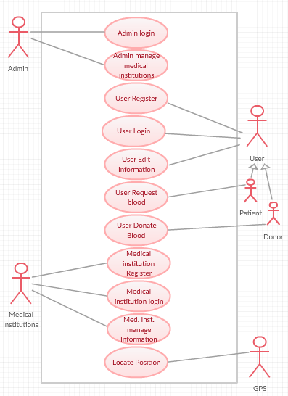

Figure -usecase

## 4.3 Activity Diagram:

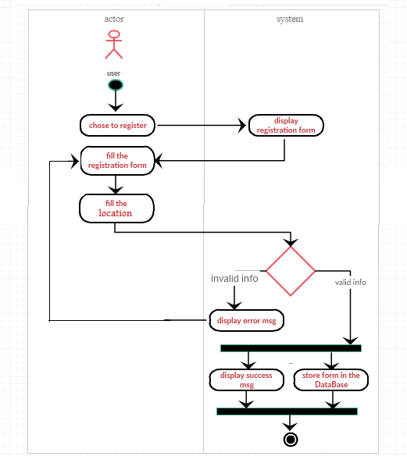

Figure 7- Activity diagram for user registration

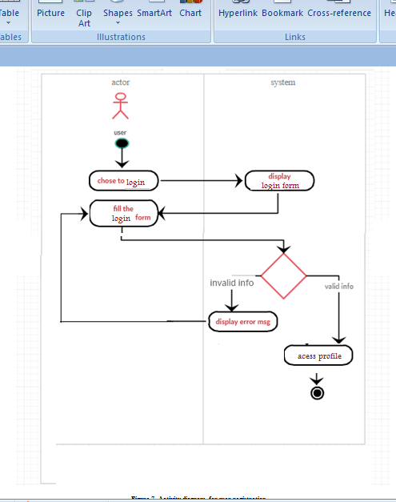

Figure 8 activity for login

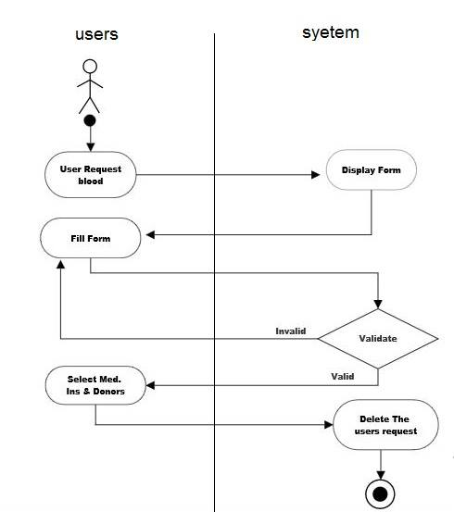

Figure 9-Activity diagram for user request blood

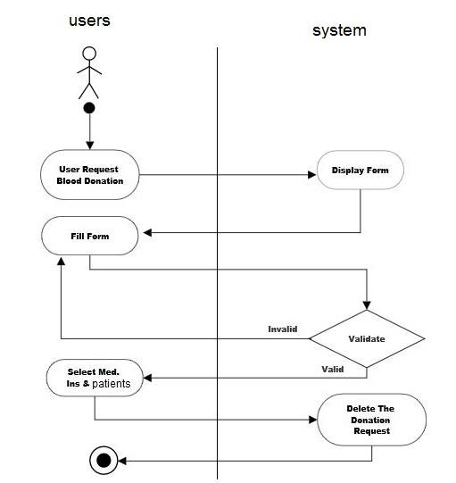

Figure 10-Activity diagram for user donate blood

## 

## 4.4Sequence Diagram:

## 

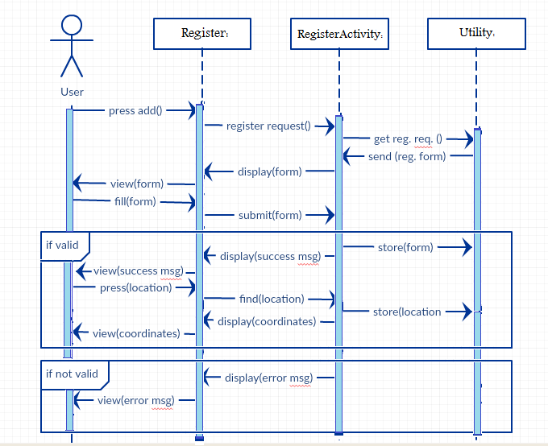

Figure 11- sequence diagram for user registration

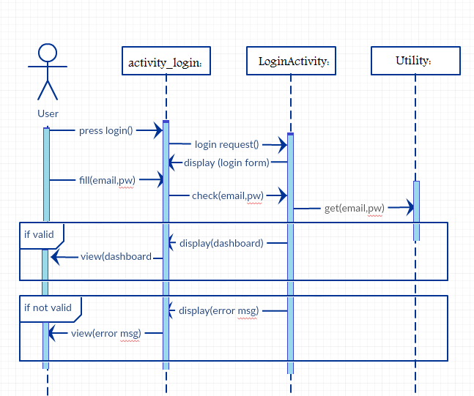

Figure sequence login

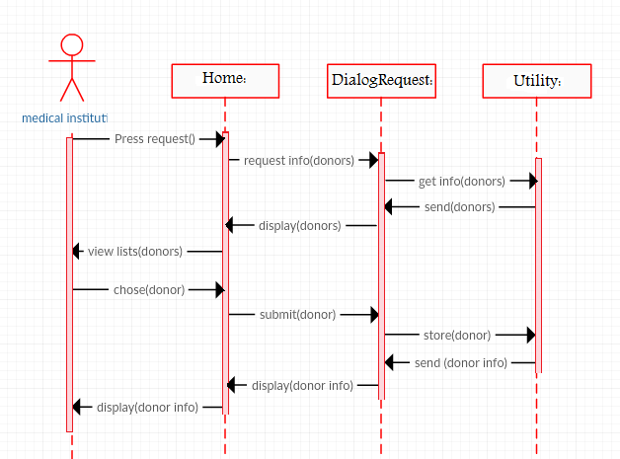

Figure 13- sequence diagram for user request blood

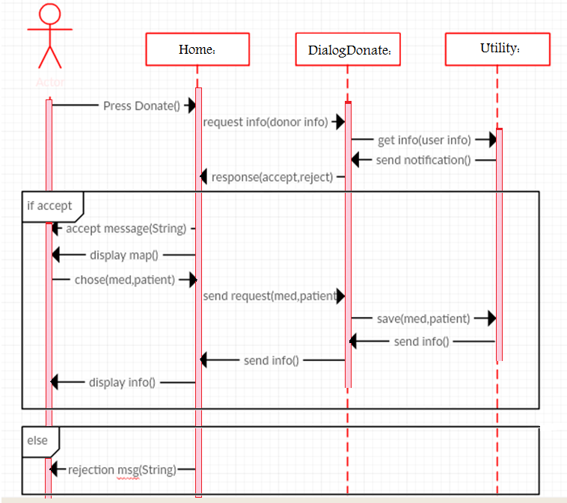

Figure 14-- sequence diagram for user donate blood

4.5 Statechart Diagram:

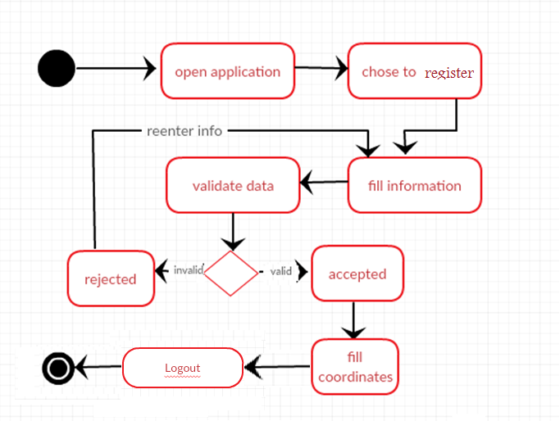

Figure 15- statechart user registeration

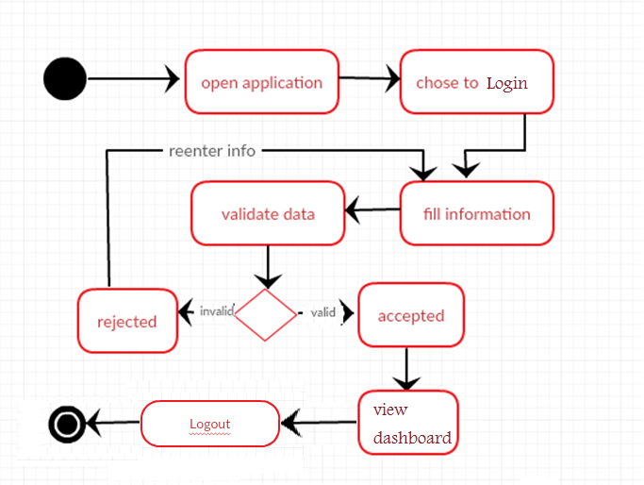

Figure statechart login

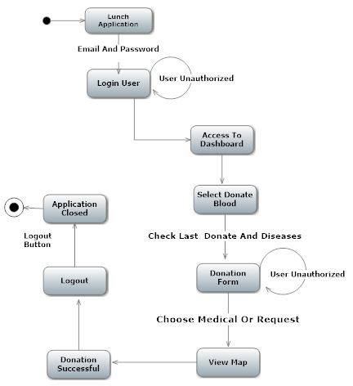

Figure statechart donate blood

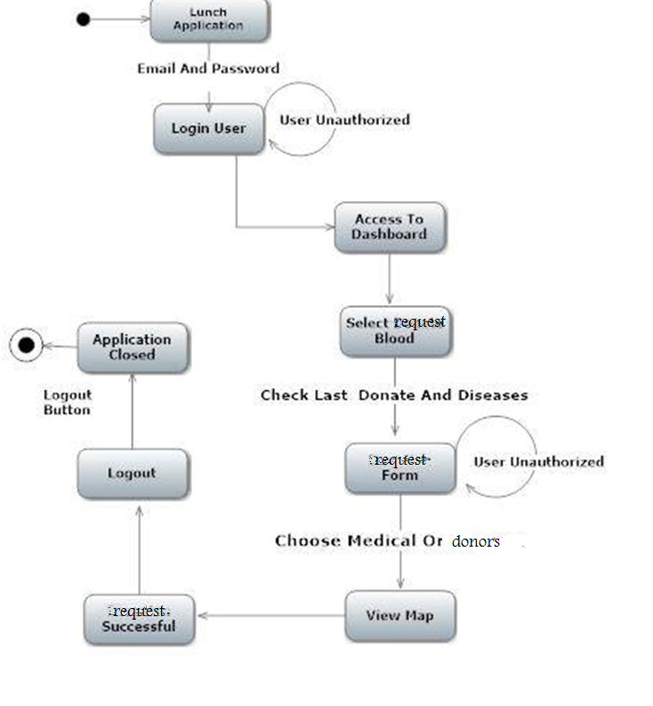

Figure 18satetchart forrequesting blood

4.6 component diagram  
  
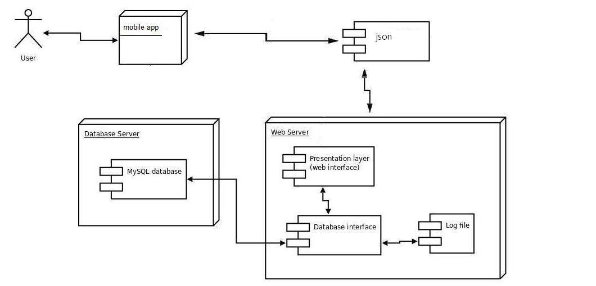

Figure component diagram

## 4.7 ERD Diagram

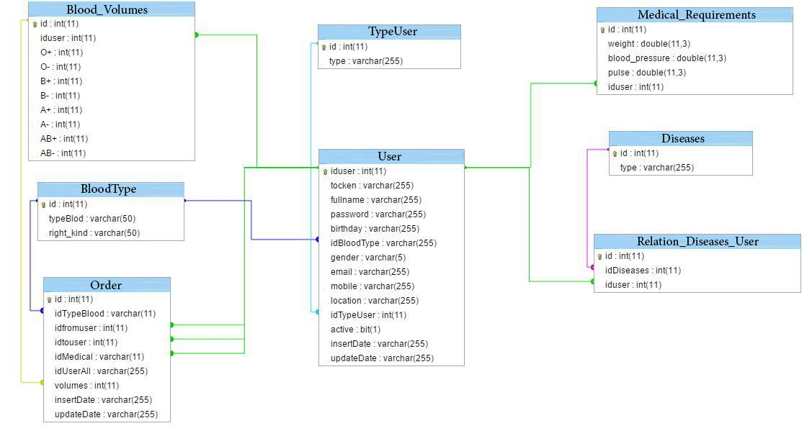

Figure ERD Diagram



Figure class diagram

# 

# 

# 

# Chapter V

# Implementation

**5. Implementations**

## 5.1 Process Model

The process model used for developing this software is the agile model, because the beginning we didn’t have clear requirements, when we developed this a application we had meetings every period of time with our supervisor, then work as a sprint for each sprint we make sprint planning ,development and sprint review then we go to the next sprint . we used this model process because through this process we gave attention to technical excellence and good design, Adaptation to changing circumstances. Even late changes in requirements are welcomed.

### 5.2 Main features

#### 5.2.1 Feature no.1: donate blood

• Use case: (3)

• Functional Requirements: (FR7, FR8, FR10, FR11, FR15).

• Non Functional Requirements: (NFR1, NFR2, NFR3, NFR5)

Description: The mobile application allow to user to donate blood to patients or to medical institutions.

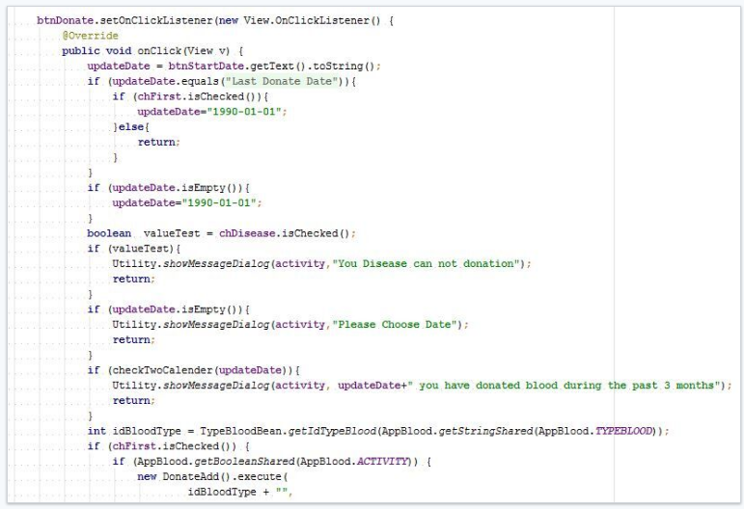

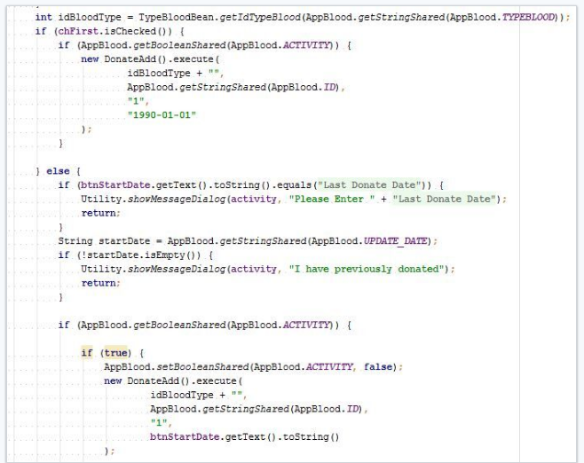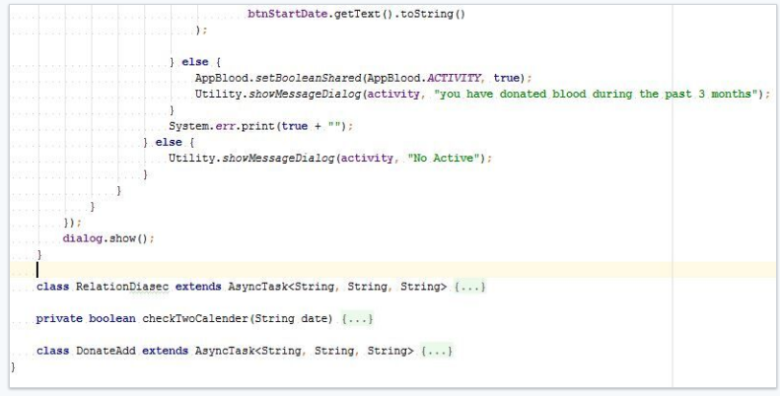• Requirements complete/Incomplete list:

|  |  |
| --- | --- |
| Requirements Complete | Requirements Incomplete |
| Functional (FR7, FR8, FR10, FR11, FR15).  Non Functional: (NFR1, NFR2, NFR3, NFR5) | None |

#### 5.2.1 Feature no.1: request blood

• Use case: (4)

• Functional Requirements: (FR9, FR10, FR12, FR13, FR14).

• Non Functional Requirements: (NFR1, NFR2, NFR3, NFR5)

Description: The mobile application allow the user to request blood from a medical institution or from a don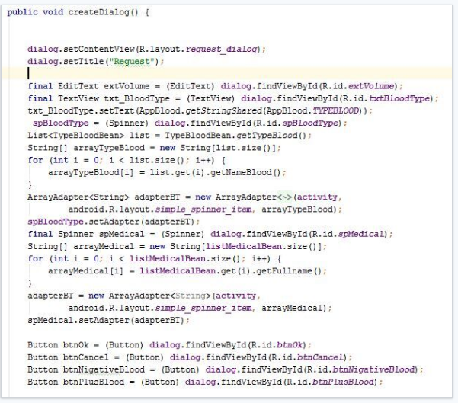

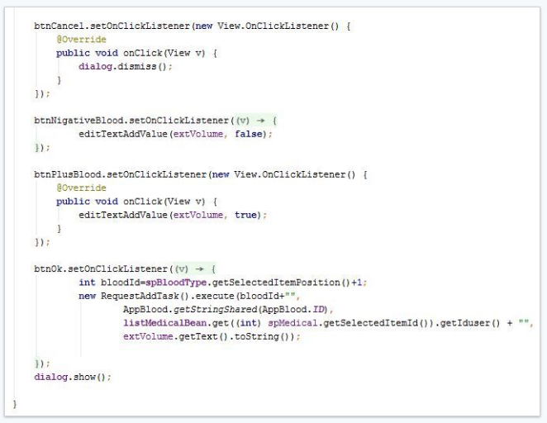

• Requirements complete/Incomplete list:

|  |  |
| --- | --- |
| Requirements Complete | Requirements Incomplete |
| Functional (FR9, FR10, FR12, FR13, FR14).  Non Functional☹ NFR1, NFR2, NFR3, NFR5) | None |

## 6. Testing

### 6.1 Requirement Testing

#### 6.1.1 Functional Requirement testing :

Table 5 Function Req. Test

|  |  |  |  |
| --- | --- | --- | --- |
| **Req. No** | **Input** | **Output** | **Result** |
| **1** | The system shall allow the users to enter their information. | Show info about the user. | 100% Done |
| **2** | The system shall allow the users to register to the application. | The user is registered | 100% Done |
| **3** | The system shall determine user’s location. | The users location is displayed. | 100% Done |
| **4** | The system shall allow the user to login to the application | The user is logged in. | 100% Done |
| **5** | The system shall allow the users to edit their information. | The information is edited. | 100% Done |
| **6** | The system shall allow the users to view a map with details. | The map is displayed. | 100% Done |
| **7** | The system shall allow the user to enter the blood group they are looking for. | The blood group is entered. | 100% Done |
| **8** | The system shall allow the user to request blood. | The system displays data on map | 100% Done |
| **9** | The system shall allow the user to donate blood. | The blood is donated. | 100% Done |
| **10** | The system shall allow the user to search for the medical institution | Medical institution are displayed. | 100% Done |
| **11** | The system shall allow the user to search for the patients requests. | Patients requesets are found | 100% Done |
| **12** | The system shall allow the user to search for the blood donors. | The blood donor are found. | 100% Done |
| **13** | The system shall allow the user to contact the donor. | The blood donor is contacted. | 100% Done |
| **14** | The system shall allow the user to select a medical institution. | The med. Inst is selected. | 100% Done |
| **15** | The system shall allow the user to select a blood request. | The blood request is selected. | 100% Done |
| **16** | The system shall allow the admin to login. | The admin is logged in. | 100% Done |
| **17** | The system shall allow the admin view med. inst. list. | The med. Inst is viewed by the admin. | 100% Done |
| **18** | **.** The system shall allow the admin accept medical institutions registration request | The medical ins. Are accepted. | 100% Done |
| **19** | The system shall allow the medical institution to register. | Th med inst are registered. | 100% Done |
| **20** | The system shall allow the medical institution to determine its location. | The location is determined. | 100% Done |
| **21** | The system shall allow the medical institution to login | The med ins is logged in. | 100% Done |
| **22** | The system shall allow the medical institution to view its profile. | The profile is viewed. | 100% Done |
| **23** | The system shall allow the medical institution to update blood units. | The blood units number is updated. | 100% Done |
| **24** | The system shall allow the medical institution to edit donor’s info | The donors info is updated. | 100% Done |
| **25** | The system shall allow the medical institution to view requests info | The request is viewed. | 100% Done |

#### 6.1.2 Non-functional requirements testing :

Table 6 Non-Functional Req. Test

|  |  |  |  |
| --- | --- | --- | --- |
| **Req. No** | **Input** | **Output** | **Result** |
| **1** | The systems colors shall be attractive. | The application interface is attractive. | The interface is clear. |
| **2** | The system’s interface shall be easy to use. | The interface is easy to use. | Interface is easy to use. |
| **3** | The systems maps shall be fast. | The maps are fast. | The maps are fast. |
| **4** | The Application Shall Be Available 24 hours | the system is available 24 hours | the system is available 24 hours |
| **5** | Only users that have account can access to the application. | The application is secure. | The application is secure. |

### 6.2 System Testing

In this section of the document, a list of the goals that were set out at the beginning

Stages of the project are going to be tested against the measurements it was given where the actual result will be compared to the expected one.

#### 6.2.1Test case for Goal no.1

Purpose: Assist hospitals and patients to find blood group

Measurement : save time 100%

|  |  |  |
| --- | --- | --- |
| **Goal purpose (Input)** | **Goal purpose (Output)** | **Goal’s actual result** |
| Assist hospitals and patients to find blood group | reduce the time spent on searching for hospitals and health centres by 100% since the blood banks database shall be available for users all the time. | 100% completed |

Discussion : requesting blood shall me much easier

#### 6.2.2 Test case for Goal no.2

Purpose : to encourage people to donate blood more often.

Measurement : the percentage of blood donors shall be increased above the yearly percentage 5%.

|  |  |  |
| --- | --- | --- |
| **Goal purpose (Input)** | **Goal purpose (Output)** | **Goal’s actual result** |
| to encourage people to donate blood more often | the percentage of blood donors shall be increased above the yearly percentage 5%. | 100% completed |

Discussion : blood donation shall be much easier

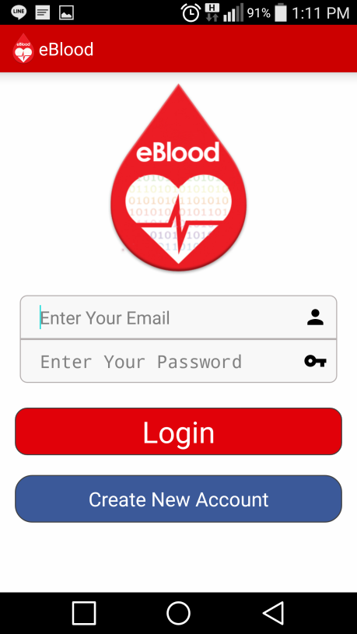

1. **Enter email .**
2. **Enter password.**
3. **Login .**
4. **Create New Account.**

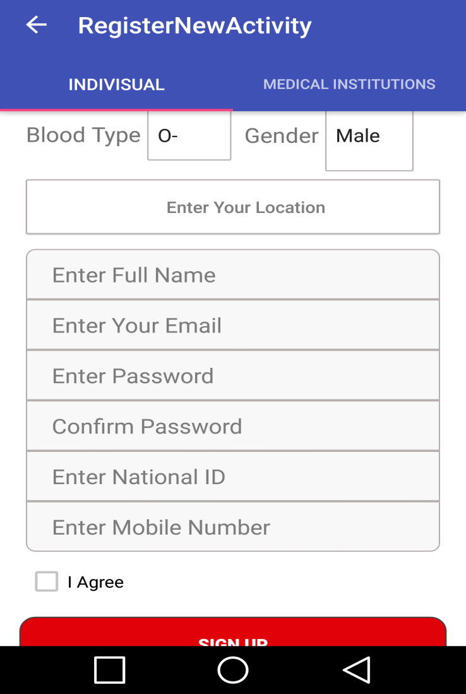

1-Select Your Blood Type.

2-Choose Gender.

3-Enter Your Location.

4-Enter Name.

5-Enter Email.

6-Enter Password.

7-Enter Password Again.

8-Enter National ID.

9-Enter Mobile Number.

10-Enter Sign up.

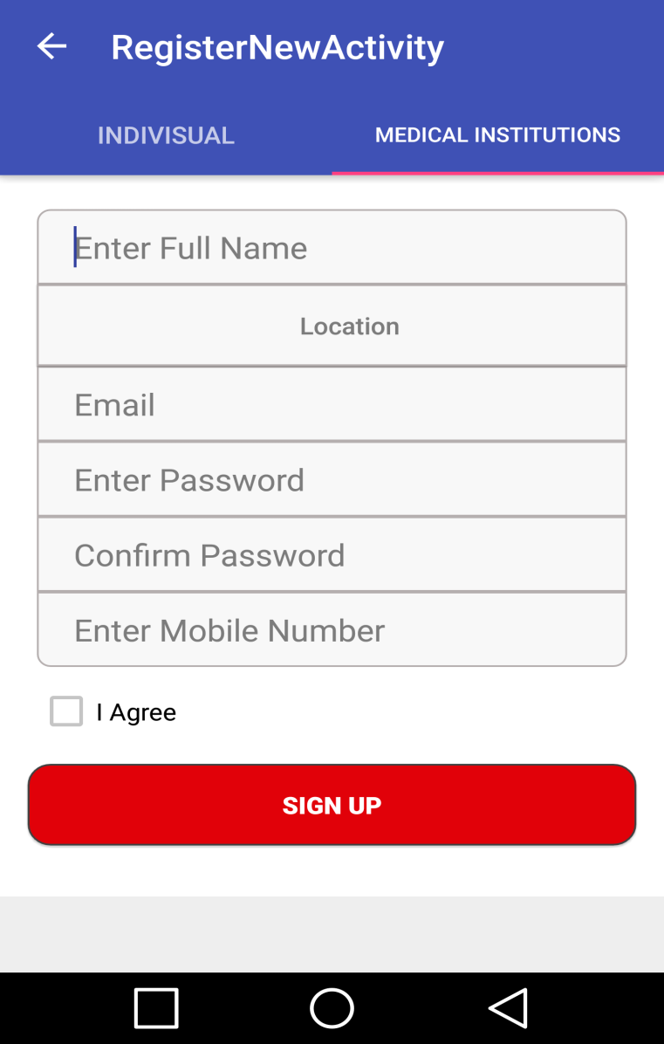

1-Enter Name.

2-Enter Your Location.

3-Enter Email.

4-Enter Password.

5-Enter Password Again.

6-Enter Mobile Number.

7-Enter Sign up.

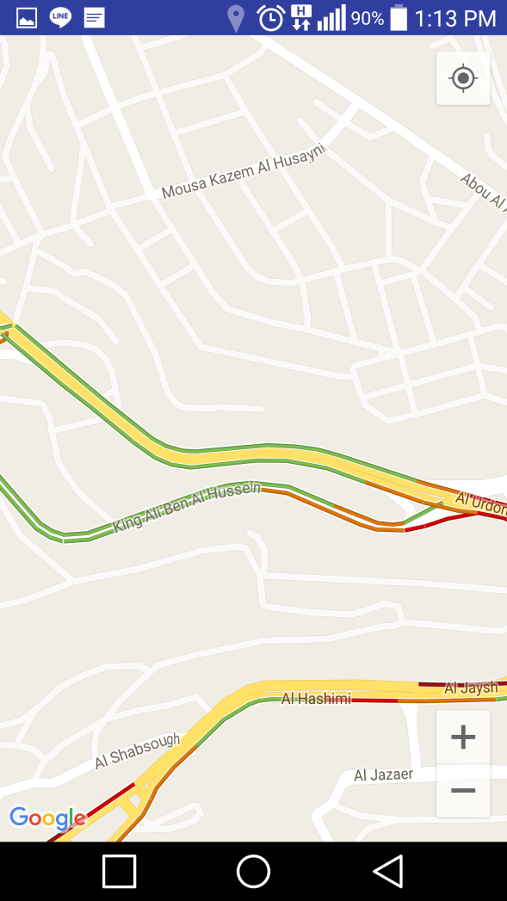

1-Select Your Location.

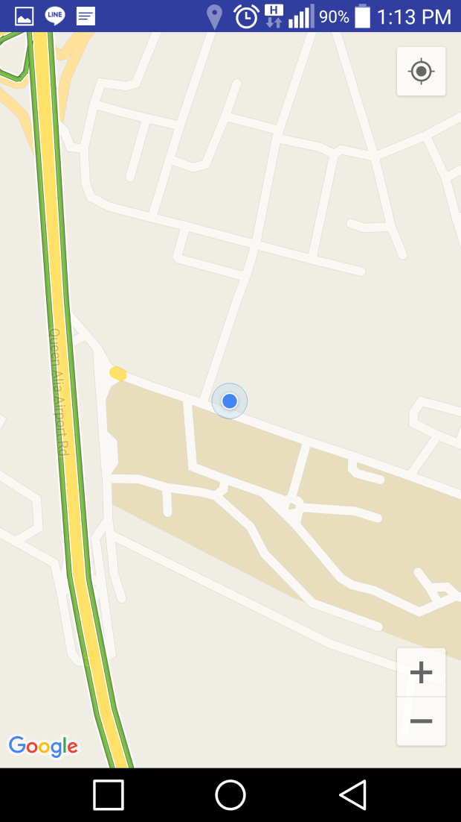

1-Your Location.

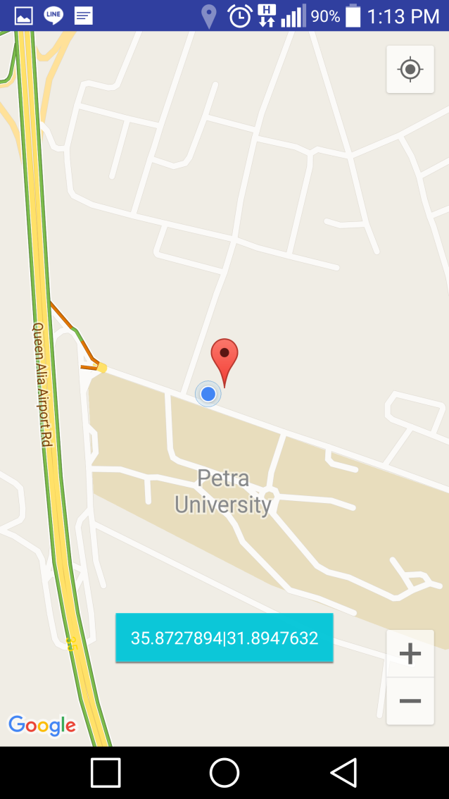

1-Your Location.

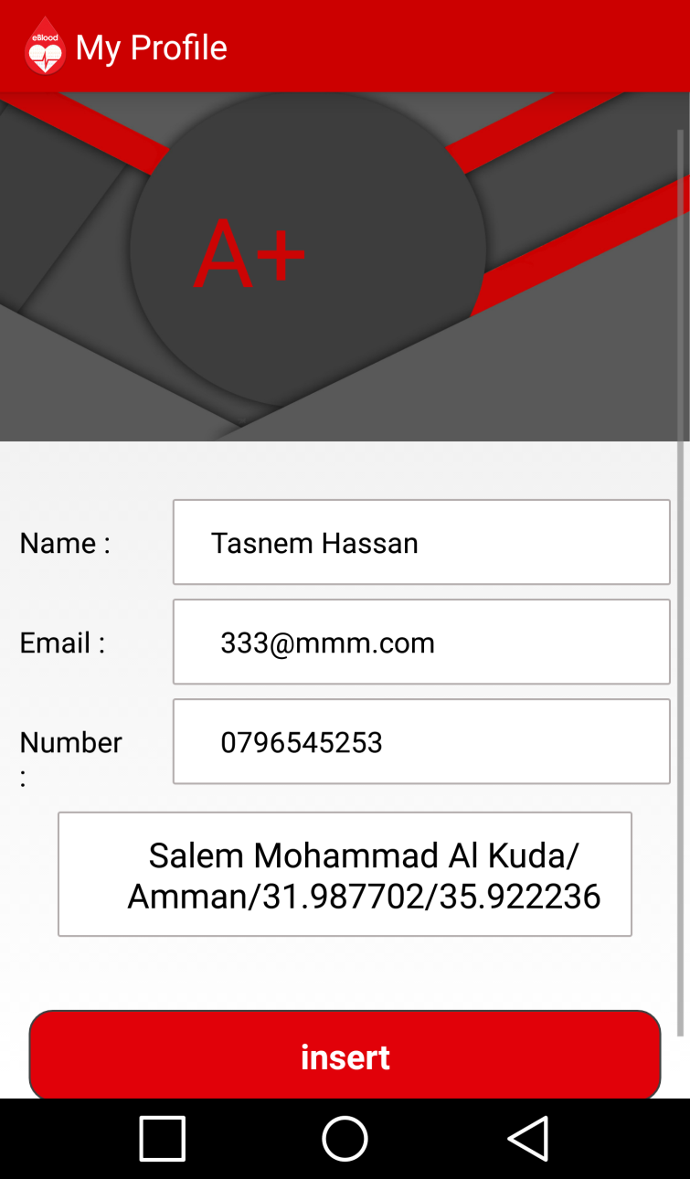

1-Enter Name.

2-Enter Email.

3-Enter Mobile Number.

4-Enter Your Location.

5-Enter Insert.

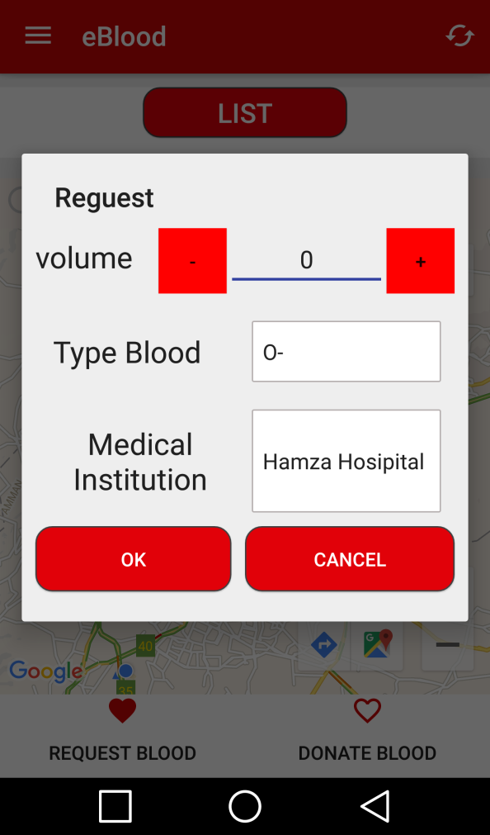

1-Minus Volume.

2-Plus Volume.

3-Select Type Blood.

4-Select Medical Institution.

5-Cancel.

6-Enter Ok.

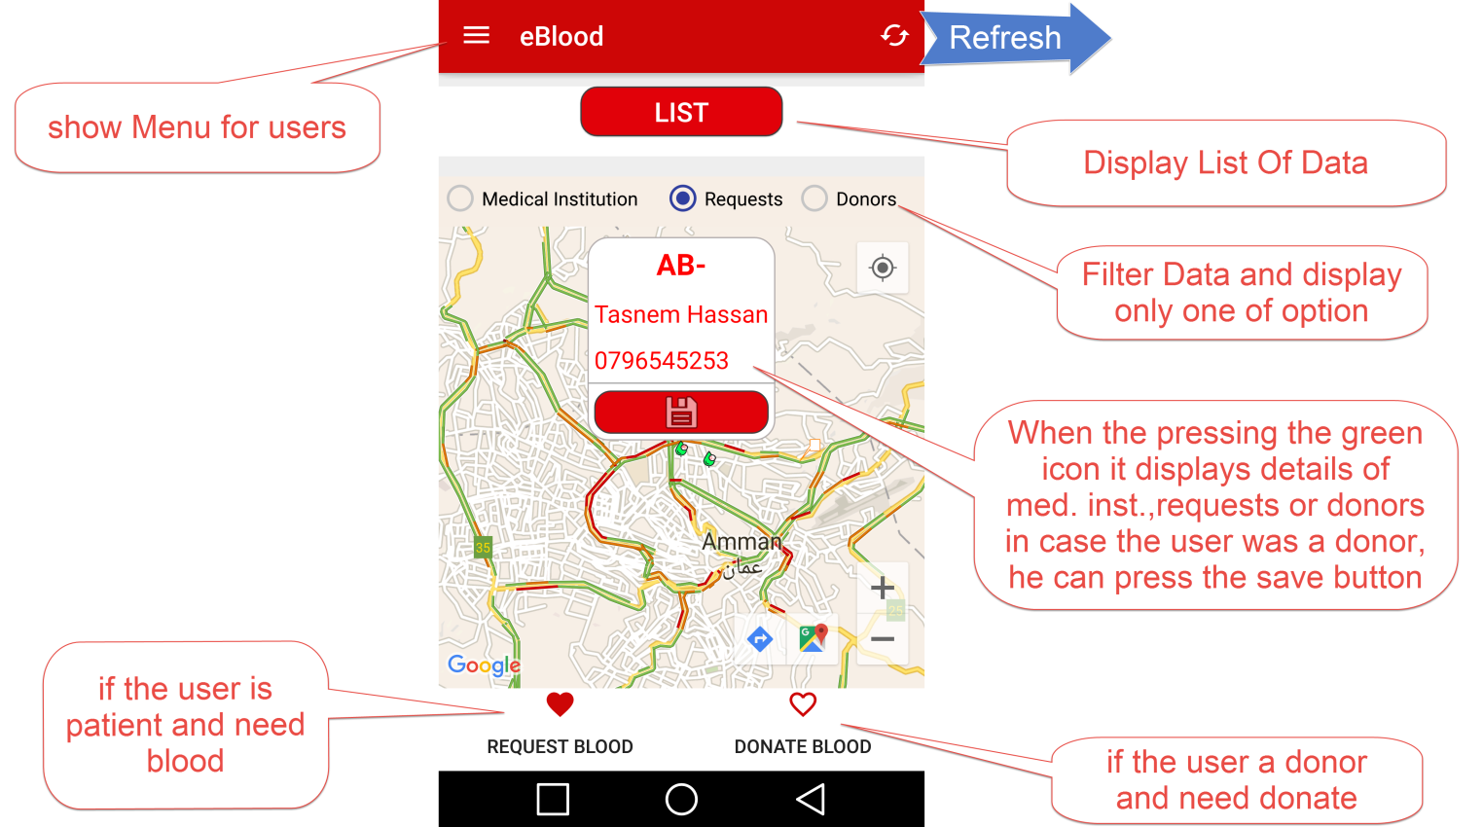

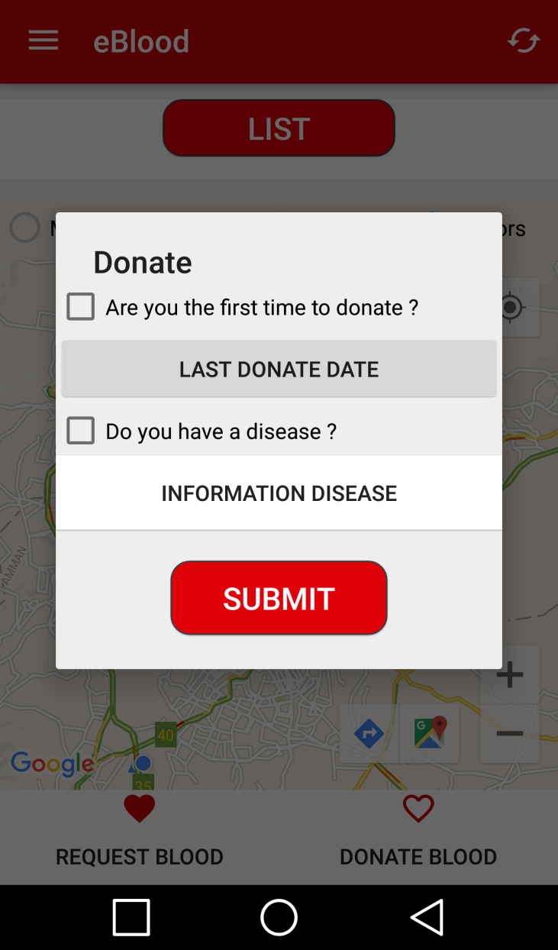

1-Check Are You The First Time To Donate.

2-Enter Last Donate Date.

3-Check Do You Have a Disease.

4-Information Disease.

5-Enter Submit.

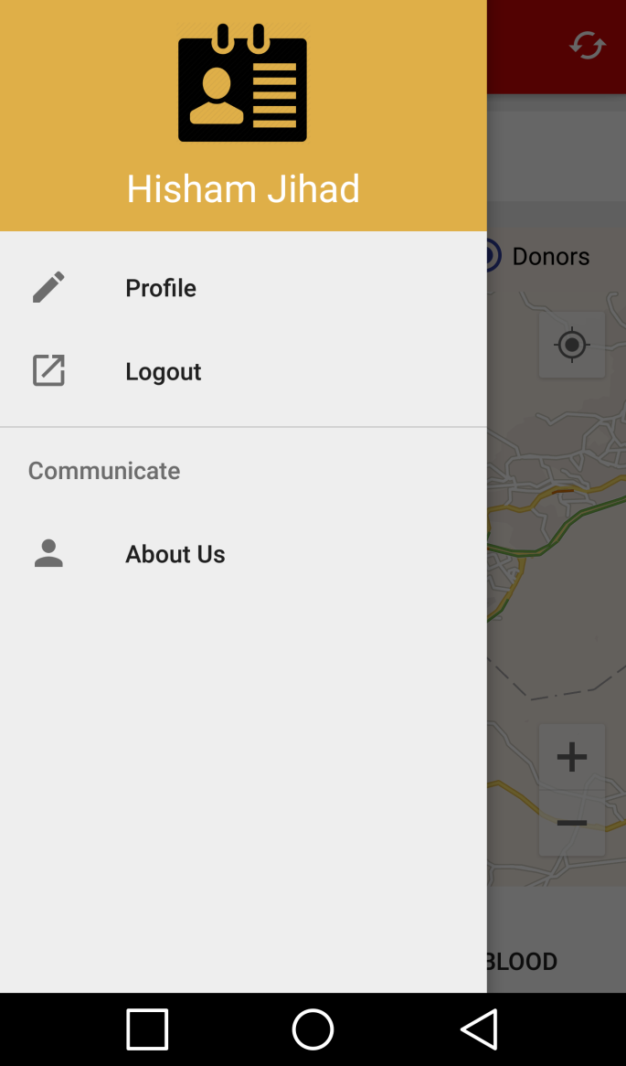

1-Your Profile For Edit and View Information User.

2-Logout App.

3-About Us.

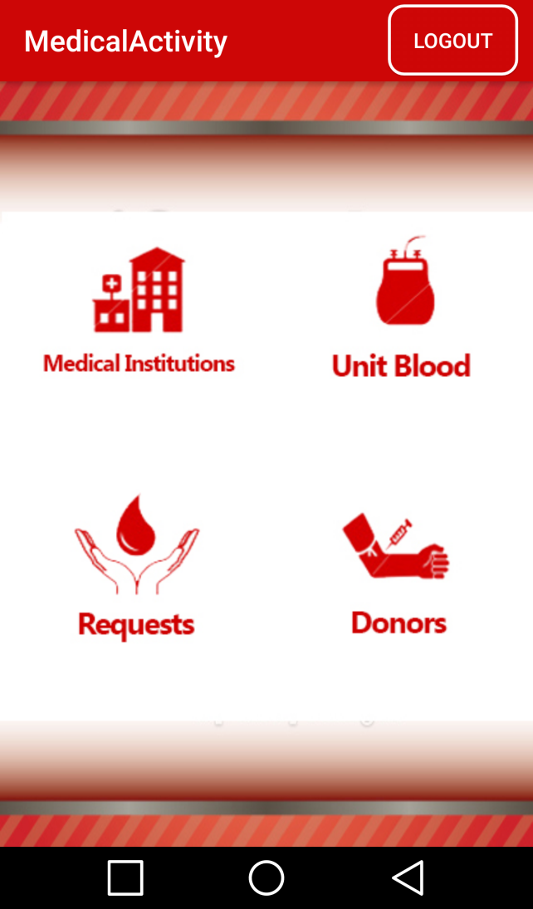

1-Information Medical.

2-Edit and View Unit Blood.

3-Show Donors and Edit Info.

4-Show Requests and Edit Info.

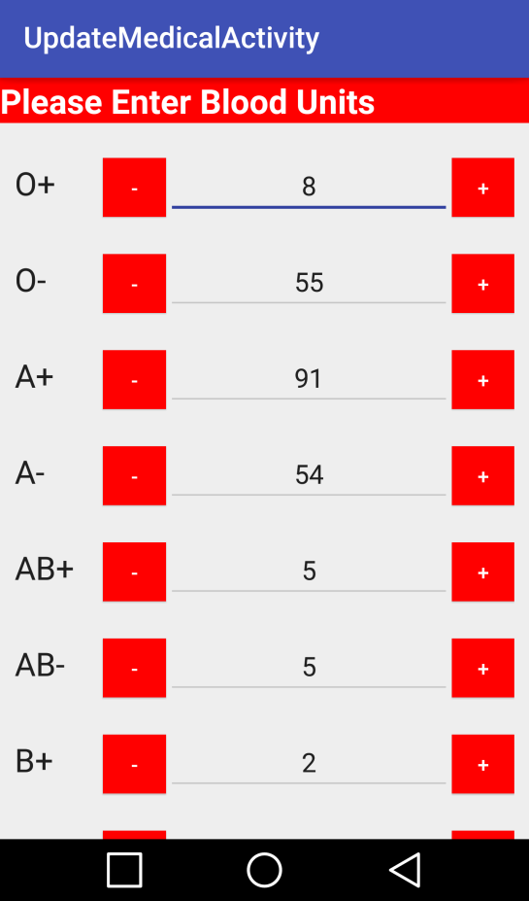

1-Add Unit Blood.

2-Subtraction Unit Blood.

3-Blood Type.

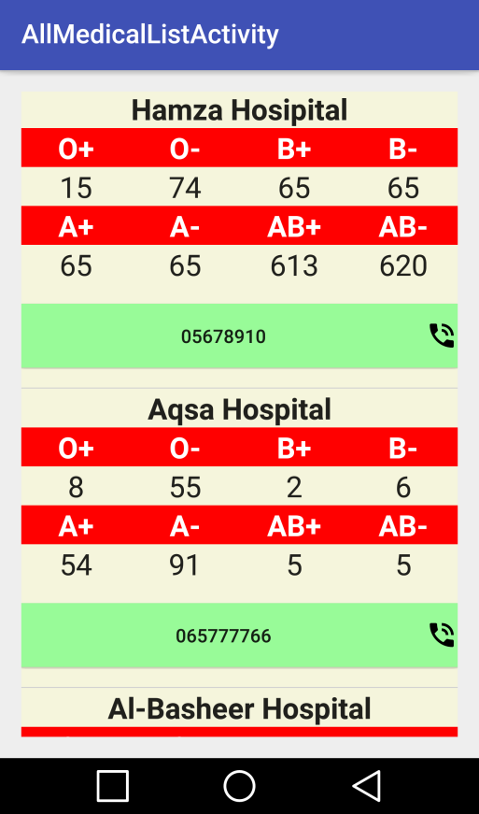

1-Hospital Name.

2-Blood Type and Number Of Units.

3-Click on Button To Call hospital.

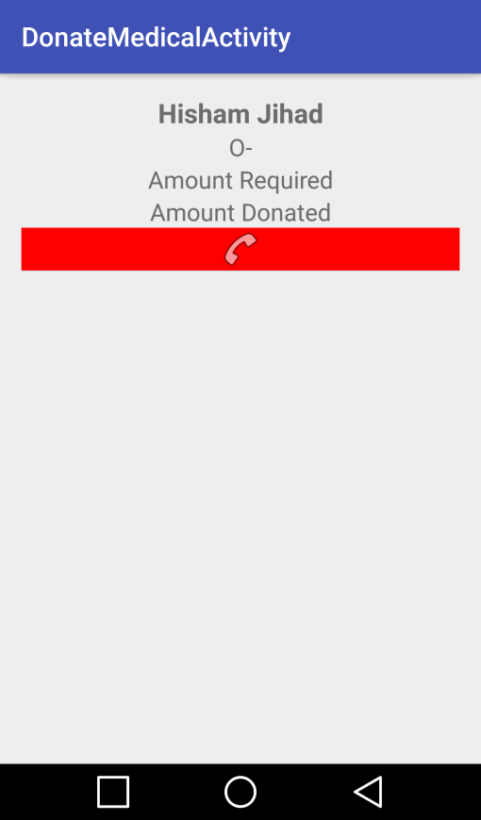

1-User Donate.

2-Show Amount Required.

3-Show Amount Donate.

4-Click on Button To Call User.

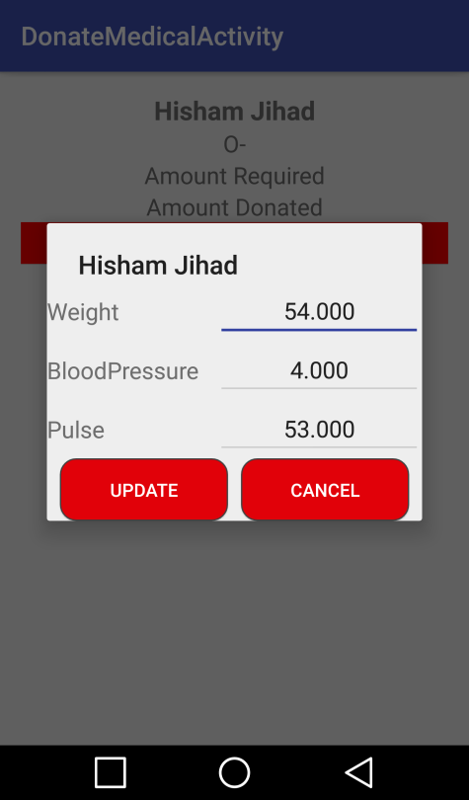

1-Enter Weight.

2-Enter BloodPressure.

3-Enter Pulse.

4-Cancel.

5-Enter Update.

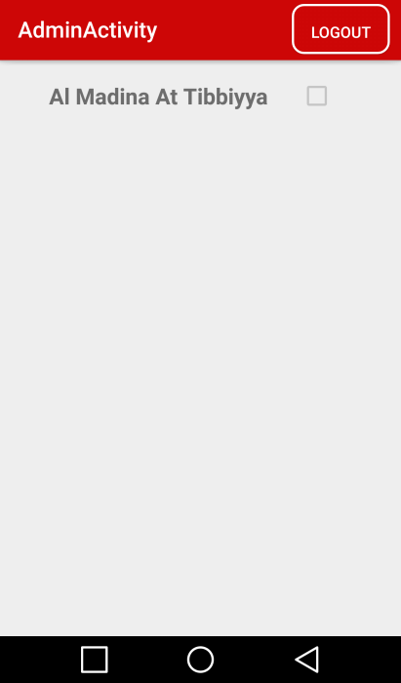

1-Logout Admin.

2-Check The Box For Send Information To Database

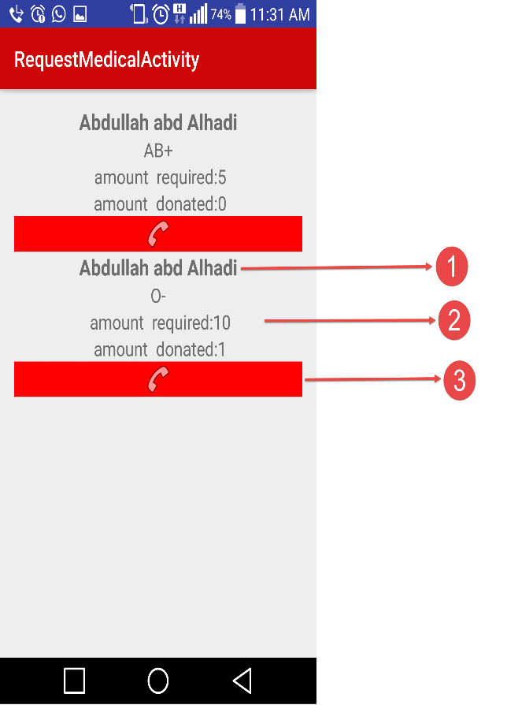

1- Request Name.

2- If Check Item To View Donors.

3- Call Request.

\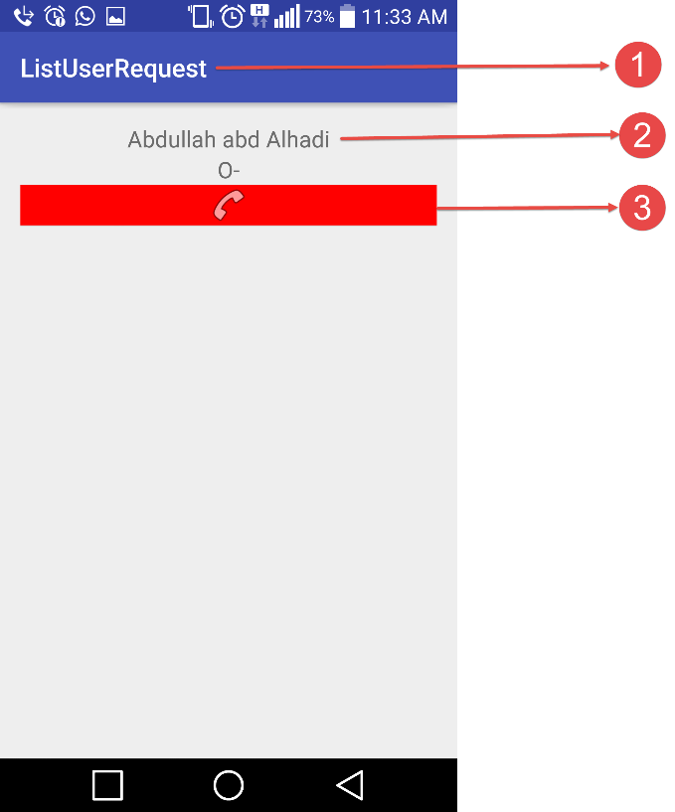

1- List Of Donors Request

2- Name Of Donor after clicked it show Dialog to Complete Information Donor

3- Call The Donor

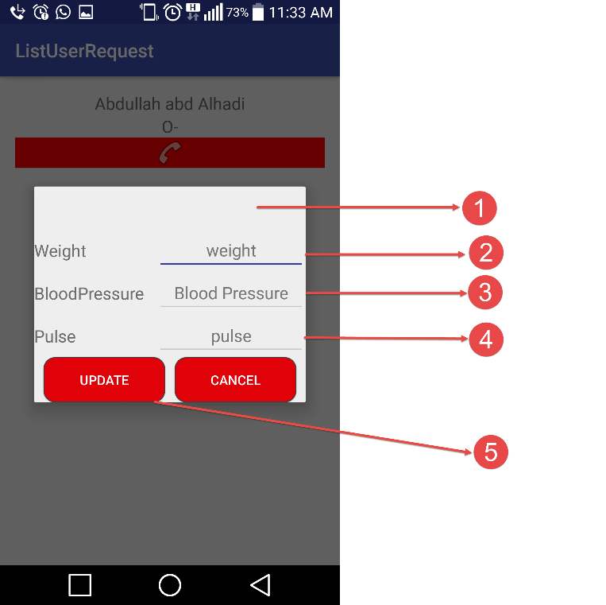

1- Dialog Of Donors in Request

2- Fill Weight Of Donor

3-Blood Pressure Of Donor

4- Pulse Of Donor

5- Update Inforamtion Donor

### Conclusion and Future Improvements

## Conclusion

This application aims to save lives and help people to live a healthy life. It saves money, time and effort. Our aim was to provide a complete application to help people and that’s what we did.

## Future Improvements

Improvements that we aspire to carry out but the time constraints we were unable to do:

1. Allow the medical institutions to exchange blood units among each other.

2- Develop a website to ease the process for medical institutions and to use the website by multiple employees.

**References:**

* Borreli, L. (2013) *Why donating blood is good for your health*. Available at: http://www.medicaldaily.com/why-donating-blood-good-your-health-246379 (Accessed: 22 March 2016).
* Centers, A.B. (1999) *America’s blood centers*. Available at: http://www.americasblood.org/about-us/staff.aspx (Accessed: 23 March 2016).
* Fitness (2015) *Blood members Nepal - Android Apps on Google play*. Available at: https://play.google.com/store/apps/details?id=c25.niroj.bloodmembers&hl=en (Accessed: 25 March 2016).
* Grimshaw, J.M. and Russell, I.T. (2008) ‘Effect of clinical guidelines on medical practice: A systematic review of rigorous evaluations’, *The Lancet*, 342(8883), pp. 1317–1322.
* Medical, letsnurture (2015) *Blood monk - Android Apps on Google play*. Available at: https://play.google.com/store/apps/details?id=com.letsnurture.bloodmonk&hl=en (Accessed: 25 March 2016).
* Mollison, P.L., Engelfield, C., Contreras, M. and Engelfriet, C.P. (1997) *Blood transfusion in clinical medicine*. 10th edn. Malden, MA, USA: Blackwell Science.
* Rudman, V. and Rudmann, S.V. (2005) *Textbook of blood banking and transfusion medicine*. 2nd edn. Philadelphia: Elsevier, Saunders.
* Turhan, A.G. (2012) ‘BCR-ABL expression in leukemic progenitors and primitive stem cells of patients with chronic myeloid leukemia’,CORRESPONDENCE, 119(12), pp. 2964–2965. doi: 10.1182/blood-2011-12-396226.

# Appendix A:

Interviewee: Dr. Firas Nafith Al-Mohtaseb Date: 2/4/2016  
Interviewer: Abdullah Abdul Hadi Subject: Blood Donating

1. **How the blood transfusion procedure is done?**

At first, we must make sure that the donor is healthy and able to do the blood donation, then we prepare him for the blood transfusion inside the lab, we make sure he feels comfortable, we also have a medical crew to help him in case he faint out of something, then we provide him with some healthy food and drinks to make sure he is OK and can stand up on his feet. Then we take the blood unit to do some tests on before adding it to our blood stock.

1. **What type of blood does the blood banks always seeks or asks for mostly?**

-O and –A, mostly –O.

1. **Can you please show us the forms and applications that the donors must fill before donating blood?**

Sure, you can keep the forms if you like.

1. **How much does the single blood unit cost?**

Depends on what tests you put on it, usually about 93 JDS, and the blood plasma costs 16 JDS.

Interviewee: Dr. Mohammad Younes Smadi Date: 7/4/2016  
Interviewer: Hisham Abu Snaimeh Subject: Blood Donating

1. **As a campaigns coordinator, do you deal with blood banks of private or public Hospitals?**

We deal with both, depends on who asks for blood, or depends on who supports our campaign.

1. **Does the procedure of blood transfusion differ from a private to public hospital?**

Not really, but if you give blood for public hospitals they give an insurance for a small period of time sometimes.

1. **Are there any contraindications for blood donation?**

Yes of course, the donor’s age, health, level of blood hemoglobin .

1. **What kind of medication that prevent the donor from donating blood?**

Some antibiotics , and many other medications according to the hospital polices .

1. **What level of blood haemoglobin shall be the donor’s blood?**

For males: more than 13, and females: more than 11.

1. **What kind of diseases that prevent the donor from donating blood?**

Kidney disease, Hepatitis, AIDS and Diabetes , plus the donor mustn’t have any kind of medications in the last 72 hours. You must be symptom-free from cold, flu or fever on the day of donation.

1. **Can any blood bank support our idea and help us with our application?**

Of course, if you convince them with your idea and they can easily help you and provide you with anything you need. If you need anything just contact me.